(English title in green bold style of Times New Roman font size 14 such as) The use of artificial intelligence methods to predict income and expense trends from semi-unstructured data for accounting planning for pineapple farmers in Phitsanulok province
Author Name Surname¹, Essential Intellectual Name Surname², Essential Intellectual Name Surname², …, and Corresponding Name Surname³* (Use Times New Roman font, size 9.5)
¹Name of organization, City Postcode, Country (Use Times New Roman font, size 9.5)
²Name of organization, City Postcode, Country (Use Times New Roman font, size 9.5)
³Name of organization, City Postcode, Country (Use Times New Roman font, size 9.5)
*Corresponding author: Pramotes@plu.ac.th
Received: January 13, 2025. Revised: June 17, 2025. Accepted: June 23, 2025.
ABSTRACT (Use green bold style of Times New Roman font, size 12)
(Use Times New Roman font, size 10, no more than 350 words such as) This study examined the use of artificial intelligence (AI), specifically Natural Language Processing (NLP), to predict income and expense trends for pineapple farmers in Ban Yang Subdistrict, Nakhon Thai District, Phitsanulok Province. The research focused on processing semi-unstructured accounting data, mainly from PDF files, provided by 30 farmers with prior accounting experience. A custom NLP algorithm was used to classify financial records into payment and income categories. Three time series forecasting models—Prophet, LSTM, and ARIMA—were applied to comparatively predict future trends. LSTM excels at capturing complex long-term patterns, Prophet effectively models seasonal and event-driven fluctuations, and ARIMA is well suited for identifying linear trends and short-term changes. The results showed that ARIMA outperformed both LSTM and Prophet in terms of accuracy and explanatory power. ARIMA achieved the lowest Mean Absolute Error (MAE) of 34.1084 and the highest R-squared (R²) of 0.9901, indicating superior prediction performance. LSTM had a MAE of 71.0920 and an R² of 0.9511, showing good accuracy but with higher MAE and lower R² compared to ARIMA. Prophet had the highest MAE of 603.8044 and the lowest R² of -3.2273, reflecting poor performance. Based on these results, ARIMA is identified as the most suitable model for this dataset. ARIMA's performance improved with longer forecast periods.
Keywords: (Use Times New Roman font, size 10, number of words: 3-5 such as) artificial intelligence, income and expense accounting trend, semi-unstructured data, pineapple farmer
INTRODUCTION (Use green bold style of Times New Roman font, size 12)
(Use Times New Roman font, size 10 such as) Accounting for income and expenses is crucial for managing finances in farming, especially for pineapple farmers in Phitsanulok Province, where weather conditions and fluctuating prices impact their earnings. By tracking income and expenses, such as costs for fertilizers, seeds, and labor, farmers can assess their operations and plan their finances more effectively. However, some farmers may lack the necessary knowledge or tools to manage financial data efficiently. External factors, such as market fluctuations or weather conditions, can also affect the accuracy of income and expense forecasts. Therefore, adopting accounting practices in agriculture requires a simplified approach that emphasizes the importance of farm records for evaluating performance and supporting decision-making (Singh, 2024). Despite the challenges, accounting remains a valuable tool for managing finances efficiently and mitigating risks from uncontrollable factors.
Household accounting for farmers has been continuously promoted, as good financial management is an important factor affecting the economic stability of farming households. The recording of income and expenses in the form of unstructured data and semi-unstructured data refer to data that is not organized or structured clearly, making it challenging to manage and utilize the information (Tredinnick and Laybats, 2024). This is in contrast to structured data, which is stored in standardized formats, such as tables or databases with clearly defined fields, making management and analysis easier (Bhatt et al.,2024). When data is stored in an unstructured form, such as handwritten notes or documents without proper organization, finding the necessary information can become difficult
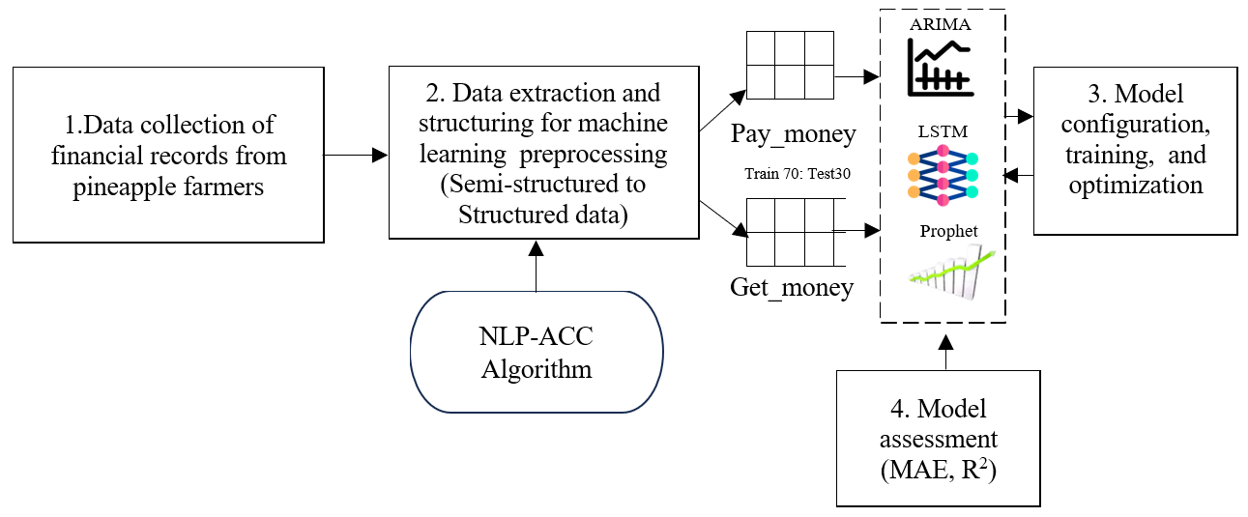
Figure 1. Research methodology steps diagram (Use Times New Roman font, size 8)

and time-consuming. For example, if someone wants to know past expenses or look up income from product sales in different seasons, semi-unstructured data can make it impossible to retrieve the information quickly, requiring significant time to compile and analyze the results. If the data can be organized using artificial intelligence-related analytical techniques (Cao et al.,2024), it can be categorized into clear sections, such as income from product sales, expenses for materials and inputs, or other costs, making data management and analysis more efficient. Moreover, having organized data helps farmers track their financial status more effectively and accurately evaluate the performance of their agricultural operations.
MATERIALS AND METHODS (Use green bold style of Times New Roman font, size 12)
(Use Times New Roman font, size 10 such as) From Figure 1, This research methodology began with the collection of financial data from pineapple farmers, including income, expenses, and related accounting information. The data are transformed from semi-structured formats into well-structured data using the NLP-ACC algorithm, making them suitable for machine learning preprocessing.
Data collection for accounting management methods of pineapple farmers (Use green bold italic style of Times New Roman font, size 14)
(Use Times New Roman font, size 10 such as) Financial data analysis, such as calculating net profit and liquidity, enables farmers to plan their long-term finances more effectively. Moreover, leveraging technology, such as accounting applications or Excel programs, adds convenience and accuracy to data recording and numerical calculations using the common accounting formulas outlined in Equations 1–3.
Total Income = Sum of all incomes (1)

Total Expenditure = Sum of all expenditures (2)

Net Income or Loss = Total Income−Total Expenditure (3)

From the study of accounting practices among farmers, it was found that fewer farmers recorded accounting data for revenue and payment summarization in the initial stages. They used an accounting form created by the Cooperative Audit Department (2009) as a structured data format, which was then input into Excel software.
Using natural language processing (NLP) techniques to understand semi-unstructured accounting data (Use green bold italic style of Times New Roman font, size 10)
(Use Times New Roman font, size 10 such as) In the field of Natural Language Processing (NLP), several new techniques have been developed to improve the efficiency of analyzing and handling text data. One of the key techniques is word embedding proposed by Mikolov et al. (2013) , which transforms words or phrases into mathematical vectors that capture the meaning of the words in context. Models like Word2Vec or GloVe are used, helping words with similar meanings to be located close together in vector space. For example, the words "expense" and "payment" will have similar vector values. This technique allows NLP models to better understand the relationships between words in a deeper and more efficient way.

Table 1. Average structured accounting data recording of 30 farmers (Use Times New Roman font, size 8, all of words in table but the column section, use bold style)
Date | Average income (Baht) | Average expenditure (Baht)
Feb 2, 2024 | 2,750 (Carry-forward cash balance) | -
Mar 3, 2024 | - | 250 (Household expenses)
Mar 5, 2024 | 2,000 (Farm wages) | 400 (Household expenses)
Mar 8, 2024 | 1,500 (Mushroom nursery wages) | 500 (Kitchen supplies)
Mar 10, 2024 | 20,000 (Loan) | 7,000 (Agricultural equipment)
Mar 12, 2024 | - | 3,500 (Fertilizers)
Mar 15, 2024 | 30,000 (Loan) | 20,000 (Bank deposit)
Mar 15, 2024 | - | 2,400 (Fertilizers and pesticides)
Mar 20, 2024 | - | 8,000 (Soil preparation)
Mar 22, 2024 | 5,000 (Pineapple sales) | 700 (Transport costs)
Mar 25, 2024 | - | 100 (Medical expenses)
Mar 28, 2024 | -

(Use Times New Roman font, size 10 such as) Another widely used technique is sentiment analysis proposed by Pang and Lee (2008), which aims to analyze the opinions or emotions expressed in text. This technique is particularly useful for evaluating feedback on products or services. For instance, the text "This product is great" would be classified as a positive sentiment, while "The product is damaged" would be classified as negative. Sentiment analysis enables a better understanding of the emotions and opinions of people online effectively.

Checking word similarity (Use italic style of Times New Roman font, size 10 such as)
(Use Times New Roman font, size 10 such as) After translation, the code uses the difflib library and the get_close_matches() function to compare the translated word with words in a predefined dictionary. This dictionary contains words related to payment (e.g., "pay", "payment", "settle") and income (e.g., "receive", "income", "profit"). The get_close_matches() function checks how similar the translated word is to the words in the dictionary, considering a similarity threshold of 70% (using the cutoff=0.7 parameter). If the translated word is sufficiently similar to a word in the dictionary, the data is categorized into appropriate lists (e.g., pay_money or get_money). In this process, difflib.get_close_matches function from Python's Standard Library identifies close matches for a given word within a list using the SequenceMatcher algorithm. It compares similarity ratios to provide a ranked list of matches that meet or exceed a specified threshold, as shown in Equation 4.

$Similarity Raio= \frac{2.M}{T_{a}+ T_{b}}$ (4)

From Equation 4, M is Number of matching elements, T_{a} is Total elements in the first sequence and T_{b} is Total elements in the second sequence.
Developing predictive accounting trend models using machine learning algorithms (Use bold italic style of Times New Roman font, size 10 such as)
(Use Times New Roman font, size 10 such as) After extracting the semi-unstructured accounting data recorded by farmers, it is categorized into two accounting types: pay_money and get_money, using the developed algorithm shown in Table 2. The categorized data in the CSV file is then organized into lists of payments and receipts, grouped by date, to create a suitable dataset for processing with time series algorithms, including Prophet, LSTM, and ARIMA. The structure of the categorized data is shown below.
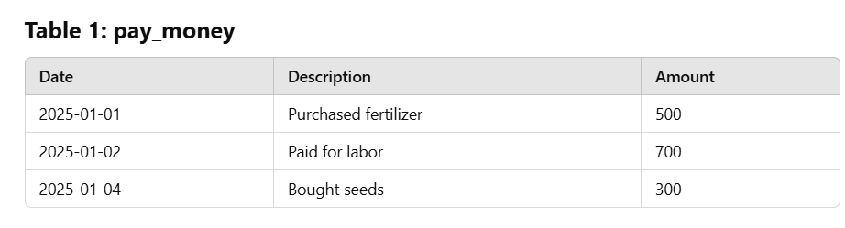
Figure 3. Pay money data table. (Use Times New Roman font, size 8)

(Use Times New Roman font, size 10 such as) In processing the accounting data recorded by farmers in CSV files, following the data structures—including dates and related amounts shown in Figures 3 and 4, the data are imported using Python’s Pandas library. This process prepares the data into a suitable format for management and analysis by converting the date columns into datetime types, enabling various models to accurately process the information.

Data preparation (Use italic style of Times New Roman font, size 10 such as)
(Use Times New Roman font, size 10 such as) The data preparation for time series modeling starts by organizing the data in chronological order, ensuring that the data is sorted by date and filling in any missing values. Then, the data is split into 70% for the training set and 30% for the testing set to preserve the chronological order and prevent data leakage, where future data would be used to predict the past.

Model configuration (Use italic style of Times New Roman font, size 10 such as)
(Use Times New Roman font, size 10 such as) The time series algorithms, including Prophet, LSTM, and ARIMA were defined with the following model configuration.

Facebook prophet (Use italic style of Times New Roman font, size 10 such as)
(Use Times New Roman font, size 10 such as) Prophet is based on an additive time series decomposition approach. Prophet is optimized for large datasets with strong seasonal patterns and is designed to handle seasonality and holidays. The model adjusts trends, seasonality, and events using either an additive or multiplicative approach. Its accuracy can be improved by fine-tuning parameters related to seasonality, holidays, and changepoints based on the data characteristics.

LSTM (Long Short-Term Memory) (Use italic style of Times New Roman font, size 10 such as)
(Use Times New Roman font, size 10 such as) LSTM is a type of recurrent neural network (RNN) that is highly effective at handling sequential data and capturing long-term dependencies in time series.
Optimized method: To enhance LSTM performance, several hyperparameters can be tuned, including the number of layers, units per layer, learning rate, batch size, and sequence length for the input data. The process begins by scaling the data using MinMaxScaler to normalize it within the range of 0 to 1. A 5-point lag sequence is then created to predict the next value in the series. The data is reshaped into a 3D format, suitable for LSTM processing, where the input data structure follows the shape (samples, time steps, features). The LSTM model consists of two layers, each with 50 units, and uses the 'tanh' activation function. To reduce the risk of overfitting, two Dropout layers with a rate of 0.2 are included. Finally, a Dense layer is used to output the predicted value. This optimization approach helps ensure accurate predictions while minimizing overfitting.

ARIMA (Autoregressive Integrated Moving Average) (Use italic style of Times New Roman font, size 10 such as)
(Use Times New Roman font, size 10 such as) ARIMA is a statistical model used for time series forecasting, consisting of three main components: 1) AR (Autoregressive): This component utilizes the relationship between the current value and past values of the data to predict future values. For example, if today’s result is related to the result of the previous day, this relationship will be used to forecast the next value, 2) I (Integrated): This component is used to make the data stationary or reduce its randomness by differencing the data over time.
The auto Arima function automatically selects the best ARIMA model by testing different combinations of autoregressive (AR), moving average (MA), and differencing parameters, and choosing the model with the lowest Akaike Information Criterion (AIC). It uses seasonal=False to exclude seasonality and stepwise=True for efficient model selection.

Experiment Method (Use green bold italic style of Times New Roman font, size 10 such as)

Performance assessment of the NLP-ACC algorithm (Use italic style of Times New Roman font, size 10 such as)
(Use Times New Roman font, size 10 such as) The performance of the NLP-ACC algorithm is assessed by examining its capability to process 150 semi-unstructured accounting data samples. The evaluation is based on the percentage of matches, which shows how accurately the algorithm detects relevant data in comparison to the total number of expected elements.
Performance assessment of predictive accounting trend models (Use italic style of Times New Roman font, size 10 such as)
(Use Times New Roman font, size 10 such as) The extracted payment accounting dataset from semi-unstructured data is used to assess the performance of time series algorithms. This dataset consists of 365 samples, split into 256 training samples (70%) and 109 testing samples (30%) for building and evaluating the predictive model. Additionally, the best model's performance in predicting data for 10, 20, and 30 days is tested. To assess the predictive model's performance, we use two main metrics:

Table 2. Pseudocode for developing NLP techniques to understand semi-unstructured accounting data (Use Times New Roman font, size 8, all of words in table but the column section, use bold style)

Algorithm: NLP-Based Approach for Semi-Unstructured Accounting Data (NLP-ACC)
Step | Action
1 | Initialize the PDF reader using PdfReader('doc3.pdf')
2 | Get the total number of pages in the PDF using len(reader.pages)
3 | Select the desired page by iterating through reader.pages[i]
4 | Extract the text from the selected page using text = page.extract_text()
5 | Split the extracted text into words using text.split()
6 | Store the split words in the list selected_text_split
7 | Store the content from the page in the dictionary datax using the page number as the key
8 | Initialize the translator using Translator()
9 | For each word in selected_text_split, translate it using translator.translate(word, src='th', dest='en'):
10 | {
11 | Store the translated word in the translated_previous_value variable
12 | }
13 | Define two lists: pay_money (e.g., "pay", "payment", "settle") and get_money (e.g., "receive", "income", "profit")
14 | For each translated word (translated_previous_value), compare it to the dictionary using get_close_matches():
15 | {
16 | Set the similarity threshold to 70% (cutoff=0.7)
17 | If the translated word is similar to a word in the dictionary, categorize the data:
18 | {
19 | If related to payment:
20 | {
21 | Add it to pay money
22 | }Else {
23 | Add it to get_money
24 }
25 }
26 | Open a CSV file for each category (corrected_data.csv, pay_money.csv, get_money.csv)
27 | Use csv.writer() to create a CSV writer object
28 | Write the header in the CSV file using writer.writerow()
29 | Write the categorized data into the file using writer.writerows()

calculated by determining the difference between the predicted values and the actual values at each data point and then finding the average of these differences., as shown in Equation 9.

$MAE= \frac{1}{n}\sum_{i=1}^{n}{y_{i}- ŷ_{i})}$ (9)

RESULTS AND DISCUSSION (Use green bold style of Times New Roman font, size 12)
Performance Assessment Results of the NLP-ACC Algorithm (Use bold italic style of Times New Roman font, size 10 such as)
(Use Times New Roman font, size 10 such as) The performance evaluation of the NLP-ACC algorithm in detecting the collected semi-unstructured accounting data from the farmers is as follows.
From Table 3, the NLP-ACC algorithm can process the accounting data recorded by farmers effectively, with an average matching percentage of 90.66%. This indicates that the algorithm performs well in detecting the expected data. Although some data categories have lower matching percentages, the overall results demonstrate the algorithm's strong performance in detecting information from semi-unstructured accounting records.

Performance assessment results of predictive accounting trend models (Use bold italic style of Times New Roman font, size 10 such as)
The extracted payment accounting dataset from semi-unstructured data is used to comparatively assess time series algorithms. This dataset consists of 365 samples, split into 256 training samples (70%) and 109 testing samples (30%) for building and evaluating the predictive model's performance.

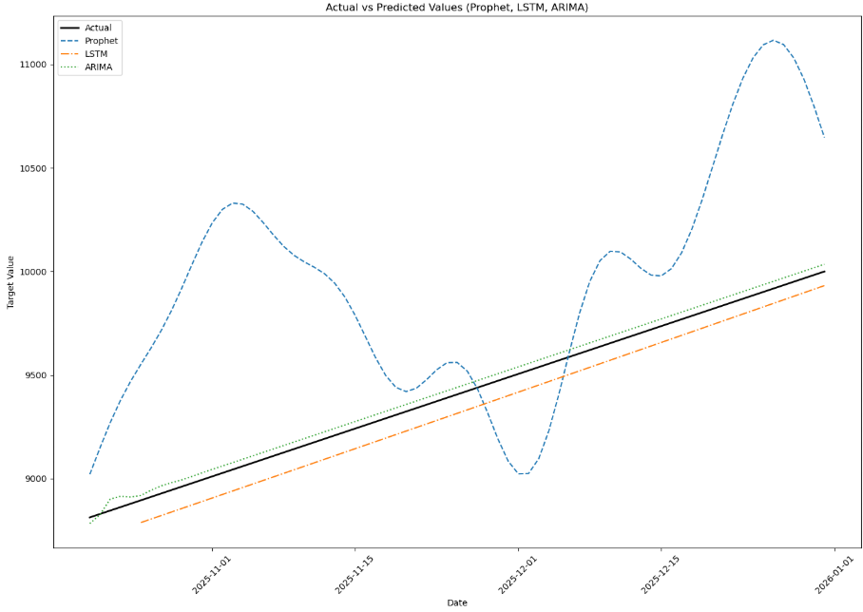
Figure 5. Comparison of predicted and actual values at the date points of the time series algorithms. (Use Times New Roman font, size 8)

Table 3: Performance of the NLP-ACC algorithm in detecting collected semi-unstructured accounting data recordings (Use Times New Roman font, size 8, all of words in table but the column section, use bold style)

Expected Data | Collected Semi-Unstructured Accounting Data Recordings (Number of Detected) | Extracted Data Using NLP-ACC Algorithm (Number of Detected) | Match (%)
Food payment | 126 | 120 | 95.24
Give money | 149 | 130 | 87.25
Car fuel | 185 | 150 | 81.08
Medical expenses | 141 | 135 | 95.74
Kitchen supplies | 157 | 140 | 89.17
Tap water | 161 | 150 | 93.17
Wages | 176 | 165 | 93.75
Loan | 154 | 130 | 84.42
Deposit | 130 | 120 | 92.31
Fertilizers/Pesticides | 149 | 140 | 93.96
Plowing | 159 | 145 | 91.19
Average Summarization | 153.36 | 138.64 | 90.66

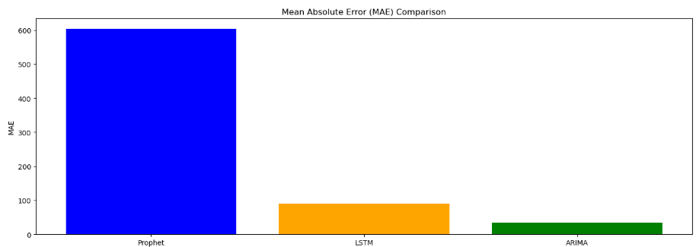
Figure 6. Comparison of MAE of the algorithms. (Use Times New Roman font, size 8)

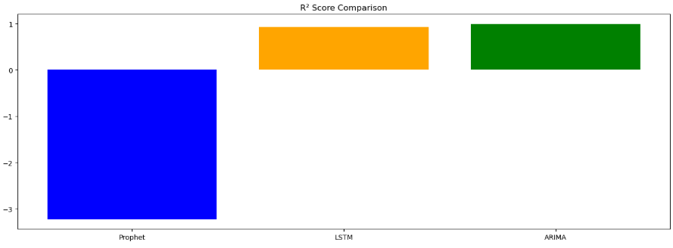
Figure 7. Comparison of R² of the algorithms. (Use Times New Roman font, size 8)

(Use Times New Roman font, size 10 such as) Figure 5 – 7, the comparison of prediction results from the Prophet, LSTM, and ARIMA models applied to the payment accounting dataset clearly demonstrates varying performance levels, with Mean Absolute Error (MAE) and R-squared (R²) used to assess each model's prediction accuracy and ability to explain the data.
MAE, or Mean Absolute Error, indicates the average prediction error of each model. In this case, the ARIMA model has the lowest MAE of 34.1084, showing the highest prediction accuracy as it predicts values closest to the actual data. LSTM has a MAE of 71.0920, indicating good accuracy but with slightly more error than ARIMA. Prophet has the highest MAE of 603.8044, reflecting the greatest
CONCLUSIONS (Use green bold style of Times New Roman font, size 12)
(Use Times New Roman font, size 10 such as) This study applied AI, specifically Natural Language Processing (NLP), to predict income and expense trends for pineapple farmers in Phitsanulok Province using semi-unstructured accounting data. The NLP-ACC algorithm effectively detected the data, achieving a high matching rate. Time series forecasting models—Prophet, LSTM, and ARIMA—were compared, with ARIMA showing the best performance in terms of accuracy and explanatory power, outperforming both LSTM and Prophet. The performance of the ARIMA model varied with the prediction period. For shorter forecasts, the model showed lower accuracy, but as the forecast period increased, both the accuracy and explanatory power improved, with the best results seen for longer prediction periods. This suggests that ARIMA performs better for longer-term predictions.
ACKNOWLEDGMENTS (Use green bold style of Times New Roman font, size 12)
(Use Times New Roman font, size 10 such as) We would like to express our heartfelt gratitude to everyone who contributed to the success of this research. Firstly, our sincere thanks go to the pineapple farmers in Ban Yang Subdistrict, Nakhon Thai District, Phitsanulok Province, who generously provided their time, knowledge, and insights into the accounting practices and the use of accounting formulas in their operations. Their participation was vital in enriching the understanding of accounting in agricultural businesses. This research would not have been possible without the contributions of all these individuals. Thank you.

REFERENCES (Use green bold style of Times New Roman font, size 12)
(Use Times New Roman font, size 8 such as)
Ali, A. A. and Masmoudi, A. 2025. Building prediction models for the e-government development index (EGDI) in Iraq and KSA: a comparative ARIMA-based approach. Fusion: Practice and Applications (FPA). 19(2): 134–150.
Bhatt, H. S., Ramakrishnan, S., Raja, S., and Jawahar, C. V. 2024. Unlocking the potential of unstructured data in business documents through document intelligence. In Proceeding of the 7th Joint International Conference on Data Science & Management of Data (11th ACM IKDD CODS and 29th COMAD) (pp. 505-509).
Blei, D. M., and Lafferty, J. D. 2007. A correlated topic model of Science. The 10th Annual International ACM SIGIR Conference on Research and Development in Information Retrieval.
Cao, S.S., Jiang, W., Lei, L., and Zhou, Q. 2024. Applied AI for finance and accounting: Alternative data and opportunities. Pacific-Basin Finance Journal. 84: 102307.
Cooperative Audit Department. (2009). Accounting form for pineapple farmers. Retrieved from https://www.cad.go.th/ewtadmin/ewt/cadweb_org/download/e_learning/acc_2009_06.pdf.
Dhawas, P., Ramteke, M. A., Thakur, A., Polshetwar, P. V., Salunkhe, R. V., and Bhagat, D. 2024. Big data analysis techniques: Data preprocessing techniques, data mining techniques, machine learning algorithm, visualization. In Big data analytics techniques for market intelligence (pp. 183-208). IGI Global.
Finkel, J. R., Grenager, T., and Manning, C. D. 2005. Incorporating non-local information into information extraction systems by Gibbs sampling. In Proceeding of the 43rd Annual Meeting of the Association for Computational Linguistics (ACL 2005).

Note: Please remove all red text before submitting to the journal.

